Volunteers’ Management System
Project Management Plan

Table of Contents

Content Page #

Table of Contents 2
1 Introduction 3
1.1 References 3
1.2 Assumptions and Constraints 3
1.3 Definitions and Acronyms 3
2 Project overview 4
2.1 Project purpose, scope, and objectives 4
2.2 Project deliverables 4
2.3 Evolution of software development plan 4
3 Project organization 5
3.1 External Interface 5
3.2 Internal Structure 5
3.3 Roles and Responsibilities 5
4 Management process 7
4.1 Project Estimates 7
4.2 Project Plan 8
4.2.1 Phase plan 8
4.2.2 Iteration objectives 9
4.2.3 Releases 9
4.2.4 Project schedule 9
4.2.5 Project resourcing 9
4.2.6 Budget 10
4.3 Iteration plans 10
4.4 Project monitoring and control 10
4.4.1 Requirement management plan 10
4.4.2 Schedule control plan 10
4.4.3 Quality control plan 10
4.4.4 Reporting plan 10
4.4.5 Measurement plan 11
4.4.6 Risk management plan 11
4.4.7 Close-out plan 11
5 Technical Process Plan 11
5.1 Development case 11
5.2 Methods, tools, and techniques 11
6 Supporting process plans 11
6.1 Quality Assurance Plan 11
6.2 Process Improvement Plan 12
6.3 Documentation Plan 12
6.4 Training Plan 12
7 Appendices 13
7.1 Appendix A- Project change request form 13
7.2 Appendix B- Development Case and Deliverables 14
7.3 Appendix C- Project Work Breakdown Structure 15
8 Revision History 16

Introduction

This document aims to describe the overall project plan of Volunteers’ Management System for the Technical Challenge course. The theme for the project predefined by the department and it is “Using IT to improve crisis situations for citizens”.

References
- Rational Unified Process documentations and templates.
- RUP sample “Collegiate Sports Paging System Software Development Plan”.
- Wikipedia for definitions.
- Jack T. Marchewka (2009), Information Technology Project Management, Wiley
- COMINDWORK, project management portal, www.comindwork.com, access date 23.03.2010.
- TortoiseSVN, client application for source control, http://tortoisesvn.net, access date 23.03.2010.

Assumptions and Constraints
We have the following assumptions and constraints for this project:

- All members will work %50 of their available time.
- All members have internet connection while they’re working remotely.
- All members frequently check their mail inbox.
- All members will work as developers, designers and testers apart form their predefined tasks as Project Manager, Quality Manager or as an Architect.

Definitions and Acronyms
- NGO’s/Help Organization: Legally constituted, non-governmental organization created by natural or legal persons with no participation or representation of any government. In the cases in which NGOs are funded totally or partially by governments, the NGO maintains its non-governmental status and excludes government representatives from membership in the organization.
Ex:-RED CROSS, Amnesty International, Civil Defense.
- Citizen Volunteer: People working on behalf of others without being motivated by financial or material gain. Volunteering generally considered an altruistic activity, intended to promote good or improve human quality of life.
- Community: A community is a group of interacting organisms sharing an environment. In human communities, intent, belief, resources, preferences, needs, risks, and a number of other conditions may be present and common, affecting the identity of the participants and their degree of cohesiveness.
- User: Anyone uses the VMS system. Covers crisis manager and volunteers.
- Crisis: Crisis is unexpected and non-routine events or series of events that can cause trouble to the human beings normal day to day life.
- Crisis Management: The process by which an organization deals with a major unpredictable event that threatens to harm the organization, its stakeholders, or the general public.
- Volunteer’s Management System : VMS

Project overview

Project purpose, scope, and objectives
Selected project for the course is Volunteers´ Management System. Main objective of this project is to create a solution to utilize or to get benefits from regular citizens to help the people in case of any crisis.
The course will cover the last part of the overall project that is designing and developing the product Volunteers´ Management System.
This plan will provide the definition of the project, including the project’s goals and objectives, duration of the project, all organizations involved, deliverables and all documents involved.

Success of the project for this course can be defined as following list;
- Facing challenges during a real project and learn the ways of solving and preventing them.
- Learning RUP methodology in practice.
- Learning and using real industrial tools throughout the project.
- Deliver required documents in time by applying RUP Methodology.
- Design and develop whole VMS solution as specified in its SRS.

Besides the project, team has different objectives for this project. Team aims experience:
- Unified Process and iterations
- Working in diverse team members from different cultures
- Learning and using real industrial tools throughout the project.
- Get extra experience of using JAVA, .NET etc.
- Practice different roles within a project development process.

Project deliverables
The following deliverables will be produced during the project.
- Project plan (Including other sub plans like Risk management plan, etc.)
- Quality assurance plan
- Refined software requirement specification
- Software architectural document
- Software design document
- Test plan
- Test cases
- Project status and quality reports.
- User manual
- Installation guide

Evolution of software development plan
This plan will be updated for each iteration/phase for any deviations or improvements. You can see the schedule for phases in the phase plan section of this document.

Project organization
This section describes how the project is organized. Project team is divided into different teams namely, project manager team, architect team, quality assurance team, and development/designing/testing team.

External Interface
Civil Defense is the ideal target organization in Gothenburg. However, the team could not achieve communication with Civil Defense since they are busy and team has not having enough time to afford on it. No external parties are available currently.

Internal Structure
The project group consists of seven people who are master students. The team has chosen "Apollo" as the group name. The team is a flat team; no one is superior to others. The members are:

- Waseem Akhtar Soomro from Pakistan,
- Tigran Harutyunyan from Armenia,
- Abdullah Arslan from Turkiye,
- Mustafa Al-Zubaidi from Iraq.
- Abdollah Tabareh from Iran,
- Gilana Ramezani from Iran,
- Shobha BC from India,

Roles and Responsibilities
According to the new plan of the course roles, the course roles will be divided into two parts. In the first phase, there will be mainly three roles: project manager, architect and quality manager. These roles are divided among the group members. Each role will be assigned to two members; those two members will be divided into main responsible person and assistant responsible person. The main responsible person will guide the duration of course until the first deliverable and the assistant will give his/her help at the same time and both will work as a team. The other roles are developer and designer that all the group members should be responsible for it during the whole course time.

In the second phase of the course, the three main roles will be assigned by the same way to other responsible members that didn´t work as the main leads in the previous part of the course. Also all the members will take the responsibility as developers and designers.

The table below shows the roles and responsibilities:

Role | Responsibilities | First Quarter | Second Quarter
 |  | Main,Assistant | Main,Assistant
Project Manager | - Planning & estimation  - Monitoring and controlling  - Risk management  - Managing people and resources | Abdollah Tabareh,  Mustafa Al-zubaidi | Tigran Harutyunyan, Shobha BC
Software Architect | - Defining problem statement  - Developing requirement model  - Modeling solution  - Feasibility study  - High level architecture design | Abdullah Arslan,  Tigran Harutyunyan,  Waseem Soomro | Gilana Ramezani,  Abdollah Tabareh
Quality Manager | - Defining the quality assurance Plan  - Define test cases  - Plan testing efforts  - Define audits and reviews  - Report the quality of process and product | Shobha BC,  Gilana Ramezani | Mustafa Al-Zubaidi,  Abdullah Arslan,  Waseem Soomro
Designer and Developer | - Implementing the design model  - Fixing items in the test results  - Code documentation | All Group Members | All Group Members
Developer/Designer Lead | - Coordinating assigned tasks for designers and developers  - Manage and develop supporting materials for software | Waseem Soomro
Table – Role division during project

In addition to this role division, all members are responsible for all works. All members can afford little more effort/time to achieve this.

Although, all the team members have some knowledge and experience in software engineering, as master students they are not experts on software development. To overcome this, team plans frequent meetings up to two days in a week. And besides, there is a supporting supervisor and two assistants guide the team with the best practices in development process.

Management process

Project Estimates
In the Appendix C you can see the work breakdown structure of the project tasks as a diagram. The below table shows the tasks and their corresponding effort estimation as whole.

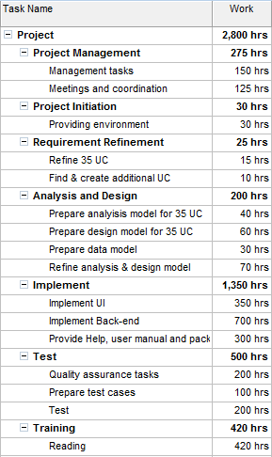
Figure - WBS together with estimations

In the following table you can see overall project schedule and phases.

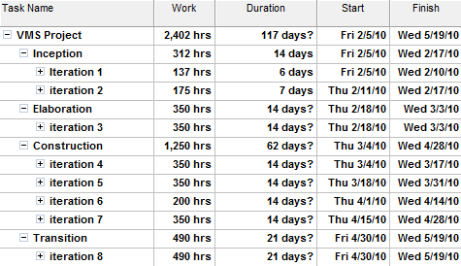
Figure - Project overall time and effort estimates

Project Plan
Here you will see some details of the project plan. For more detailed project plan please refer to MS Project file which is delivered together with this document.

Phase plan
As this project is taking phased approach, the table bellow will show some overall information about the phases in this project.

Phase | Iterations | Duration | Milestones
Inception | 2 | 2 weeks | The first major versions of project plan and quality assurance plan will be ready. The project organization will form and the environment for the project start will be ready. Staff will be trained for the activities in the next phases.
Elaboration | 1 | 2 weeks | At the end of the Elaboration phase the refined version of software requirement specification will be ready and the analysis model and design model for the software will be created based on that. Staff also will be trained for generating test cases and develop using .net and J2ME platforms.
Construction | 4 | 8 weeks | Analysis and design model of the system will be refined. 80% of functionality of the system will be realized and tested. 90% of test cases will be produced. 50% of the work for creating Help, User manual, and packaging will be done.
Transition | 1 | 3 Weeks | The remaining functionality of the system will be realized and tested and a Beta release of solution will be in hand very early in this phase. Integration test and final release tests will be preformed and Final version will be released. Help, user manual and packaging activities will be finished. The close-out project activities will be preformed and software will be delivered and demonstrated.
Table - Overall project phases information.

Iteration objectives
The following table will summarize the objectives for iterations.

Phase | Iteration | Duration | Milestones
Inception | 1 | 1 week | The kick start of the project will be hold. Staffing will be finished. A first draft of project plan and quality assurance plan will be ready. Project development environment will be ready.
Inception | 2 | 1 week | The final version of project plan and quality assurance plan will be ready. Staff training for the development for the next phase will be done.
Elaboration | 3 | 2 weeks | The refined version of software requirement specification will be ready and the analysis model and design model for the software will be created based on that. Staff also will be trained for generating test cases and develop using .net and J2ME platforms.
Construction | 4 | 2 weeks | The software requirement specification and design model will be refined. 20% of test cases will be defined. 10% of functionality of the system will be realized and 5% of them will be tested.
Construction | 5 | 2 weeks | 50% of the test cases will be defined, 30% of the functionality of the system will be realized and total tested functionality will be 25%.
Construction | 6 | 2 weeks | 80% of the test cases will be defined, 60% of the functionality of the system will be realized and the total tested functionality will be 70%.
Construction | 7 | 2 weeks | 100% of the test cases will be defined and 80% of the functionality of the system will be realized. All realized functionality will be tested and debugged.
Transition | 8 | 3 Weeks | The remaining functionality of the system will be realized and tested and a Beta release of solution will be in hand very early in this phase. Integration test and final release tests will be preformed and Final version will be released. Help, user manual and packaging activities will be finished. The close-out project activities will be preformed and software will be delivered and demonstrated.
Table – Summary of iterations for phases

Releases
At this time two releases are planned; One Beta release early in the transition phase and the final release at the end of the project.

Project schedule
You can find the complete schedule of the project in MS Project file which is delivered together with this document.

Project resourcing
Staffs for this project are from master students of IT University of Gothenburg and have the overall software knowledge and skills, but they will be self-trained during this project for specific tasks.

Budget
This project doesn’t have any budget and all resources will be provided by IT University of Gothenburg. Staff will use their personal hardware resources and the university will provide a part of hardware servers.

Iteration plans
You can find the plan for the iterations of the project in MS Project file which is delivered together with this document.

Project monitoring and control

Requirement management plan
Each requirement change should pass a predefined procedure to take effect on the project. A request for change will be submitted to project manager via filling up the form in appendix A.
Project manager will analyze and fill up the project impact related sections of the form in terms of time, cost, etc. then hand it over to project sponsor. After agreement of project sponsor and project manager and acceptance of impacts, changes to the requirements and other related subsequent artifacts defined in the traceability model of artifacts of the project will be affected.

Schedule control plan
Project status reports will be sent weekly which will include Milestone Tracking details to ensure that the project stays on track. Changes in the schedule will be escalated to the project supervisor, who will decide to alter scope in order to preserve target completion dates.

Quality control plan
Quality control plan will be addressed in Quality Assurance Plan of the project which is a separate document.

Reporting plan
Oral and written report of the status of the project will be reported weekly to the project supervisor and assistants. At the end of each iteration an iteration report will be issued separately.

Measurement plan
There are some metrics for quality of the project and the product which you can refer to Quality Assurance Plan of the project to find them out. But for tracking the project, there are some measures which will be defined as follows:

Name | Completed tasks ratio
Definition | Number of tasks that is finished and actual finish dates for them are set comparing to total number of task in the project
Goals | Works as an indicator that shows the progress of project
Analysis procedure | Number of completed tasks and number of total project tasks will be extracted from MS Project. The result from dividing the number of completed tasks by total project tasks will constitute the completed tasks ratio.
Responsibilities | Project manager
Table - Metric definition: Completed tasks ratio

Name | Earned value
Definition | A performance measurement that tells us how much of the budget we really should have spent for the work that was completed.
Goals | Works as an indicator that shows the delivered value for progress of project
Analysis procedure | Is the summation of those planned values which is completed and gained. It will be calculated in the terms of person hours in our project.
Responsibilities | Project manager
Table - Metric definition: Earned value

Name | Cost variance
Definition | The difference between a task’s or WBS component’s estimated cost and its actual cost.
Goals | Works as an indicator that shows the estimation deviation of project’s tasks. It will be calculated in the terms of person hours in our project.
Analysis procedure | Cost Variance (CV) = EV – AC.  AC stands for actual value that means the actual effort is put for the gained value.
Responsibilities | Project manager
Table - Metric definition: Cost variance

Name | Schedule variance
Definition | The difference between the current progress of the project and its original or planned schedule
Goals | Works as an indicator that shows the schedule deviation of project’s schedule. It will be calculated in the terms of person hours in our project.
Analysis procedure | Schedule Variance (CV) = EV – PV  PV stands for planned value.
Responsibilities | Project manager
Table - Metric definition: Schedule variance

Name | Cost performance index
Definition | Percentage of work completed per person hour spent
Goals | Works as an indicator that shows the estimation deviation of project’s tasks. It will be calculated in the terms of percentage.
Analysis procedure | CPI = EV ÷ AC
Responsibilities | Project manager
Table - Metric definition: Cost performance index

Name | Schedule performance index
Definition | A ratio of the work performed to the work scheduled.
Goals | Works as an indicator that shows the schedule deviation of project’s schedule. It will be calculated in the terms of percentage.
Analysis procedure | SPI = EV ÷ PV
Responsibilities | Project manager
Table - Metric definition: Schedule performance index

Name | Schedule performance indicator
Definition | A judged measurement which shows the status of scheduled work comparing to performed.  If it’s RED it means project is critically behind the schedule.  If it’s ORANGE it means the project is behind the project in a dangerous way but still it’s compensable.  If it’s GREEN it means the project doesn’t have a big lag and the schedule status of project is not so dangerous.
Goals | Works as an indicator that shows the schedule deviation of project’s schedule.
Analysis procedure | It has three values based on the value of SPI  If SPI < 60% -> RED  If 60 %<= SPI < 85% -> ORANGE  If SPI >= 85% -> GREEN
Responsibilities | Project manager
Table - Metric definition: Schedule performance indicator

Risk management plan
Refer to risk management plan document.

Close-out plan
At the end of the project, all experiences and best practices will be gathered in a meeting and will be documented for next projects.

Technical Process Plan

Development case
Please refer to Appendix B

Methods, tools, and techniques
The following tools will be used during the project development:
- MS Project 2007, project management tool.
- COMINDWORK, online project management tool.
- MS Office 2007 products (Word, Excel, PowerPoint)
- Sparx Enterprise Architect (Diagramming and modeling tool)
- NetBeans IDE 6.8, Java mobile application development tool.
- MS Visual Studio 2010, web portal and web service development tool.
- MS Sql Server.2005, database.
- Google code repository, source sharing and revisioning tool.
- TortoiseSVN, client application for repository.

The following methods and techniques will be used throughout project development.
- RUP design guidelines
- RUP test guidelines
- RUP manual style guidelines

Supporting process plans

Quality Assurance Plan
Quality assurance plan is delivered as a separate document.

Process Improvement Plan
All practices and learned materials should be documented in the project portal so others can use them.

Documentation Plan
All documents and code produced during this project will be hold in a shared repository and will be addressed in the reports for the tasks.

Training Plan
As all the members of team are not completely familiar with the domain, an appropriate amount of effort is dedicated to self reading and training. Therefore before starting a task A, another task B aiming at learning the proper way of doing task A will be provided.
The team members who have sufficient knowledge about the tasks will also guide other peoples in reading materials and way of efficient learning and will serve them as a source for questions and ambiguities.

Appendices

Appendix A- Project change request form
Project Change Request
Requested change: | Project Name:
Date of request: | Project Manager:
Business Reasons for Change:

Analysis of Change:

Project Impact of Change:
- Scope impact:

- Schedule impact:

- Budget impact:

- Risk impact:

- Other project impact:

Acceptance: Business Sponsor |  | Project Manager

Appendix B- Development Case and Deliverables

Requirements
Artifacts | How to use
Artifacts | Incep | Elab | Const | Trans
Refined Use-cases | Won’t | Must | Must | Must

Analysis and Design
Artifacts | How to use
Artifacts | Incep | Elab | Const | Trans
Software architectural document | Won’t | Could | Must | Must
Software design document | Won’t | Could | Must | Must
Data Model | Won’t | Could | Must | Must
Overall architecture description | Won’t | Could | Must | Must

Implementation
Artifacts | How to use
Artifacts | Incep | Elab | Const | Trans
Solution and source code | Won’t | Won’t | Could | Must

Test
Artifacts | How to use
Artifacts | Incep | Elab | Const | Trans
Test cases | Won’t | Won’t | Could | Must
Test plan | Won’t | Could | Must | Must

Deployment
Artifacts | How to use
Artifacts | Incep | Elab | Const | Trans
Help | Won’t | Won’t | Could | Must
User manual | Won’t | Won’t | Could | Must
Package design | Won’t | Won’t | Could | Must

Project Management
Artifacts | How to use
Artifacts | Incep | Elab | Const | Trans
Project Plan | Must | Must | Must | Must
Risk List | Must | Must | Must | Must
Progress reports | Must | Must | Must | Must

Appendix C- Project Work Breakdown Structure
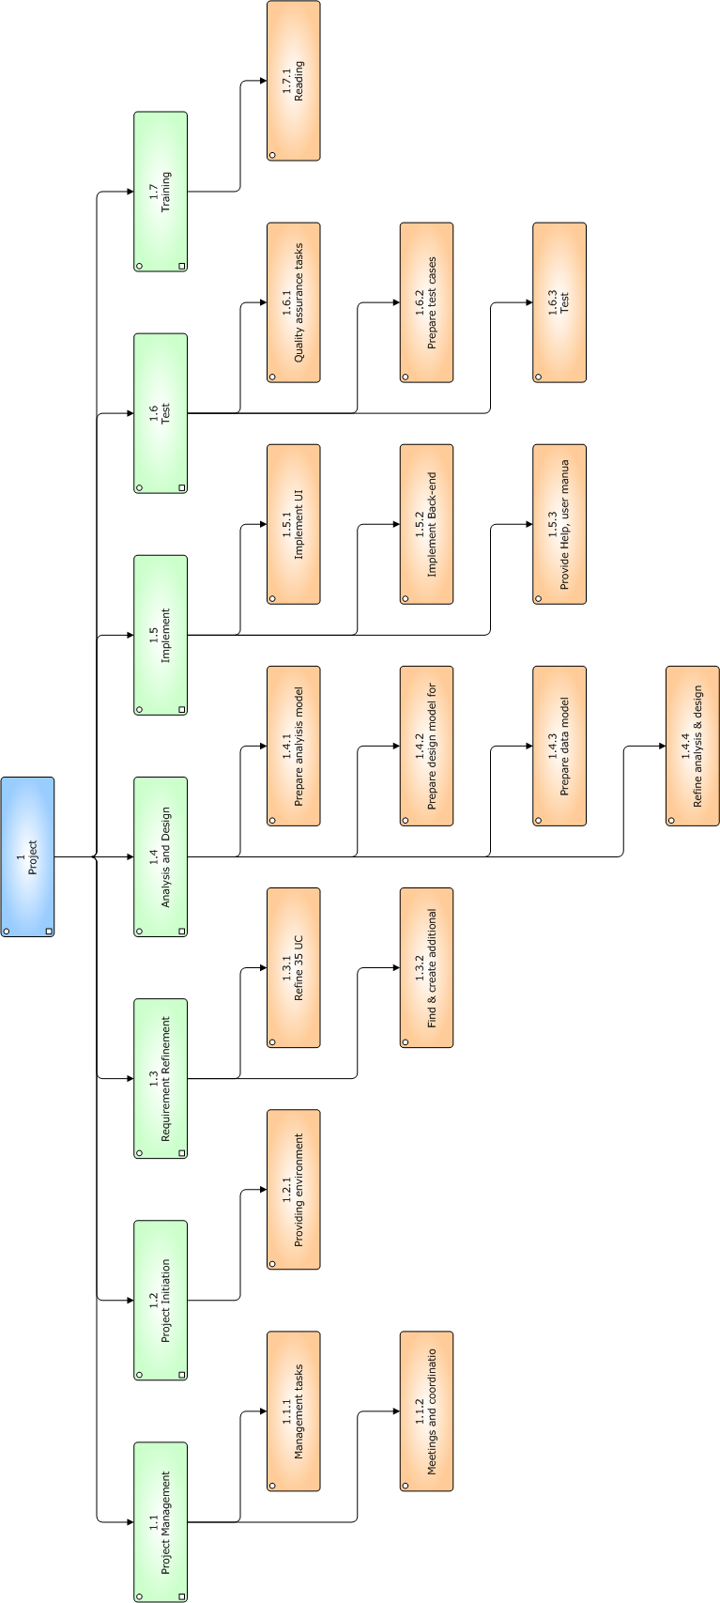

Revision History

Name | Date | Reason for Changes | Version
Mustafa Al-Zubaidi | 10 Feb 10 | Parts 1, 2, 3, review, format | 0.1
Abdollah Tabareh | 19 Feb 10 | Parts 4, 5, 6, review, format | 0.2
Shobha BC,  Mustafa Al-Zubaidi  Gilana Ramezani | 28 Feb 10 | Review by inspection | 0.3
Abdullah Tabareh | 5 Mar 10 | Defects fixed | 1.0
Tigran Harutyunyan | 23 Mar 10 | Updated iteration 5 goals. Updated Methods, tools and techniques section. | 1.1
Shobha BC | 24 Mar 10 | Reviewed the changes and also the complete document. | 1.2

